**Bahria University, Lahore Campus**

Department of Computer Science

Lab Journal 04

**(Spring 2023)**

|  |  |  |
| --- | --- | --- |
| Course: | **Data Structures and Algorithm - Lab** | Date: _16-3-2023_ |
| Course Code: | CSL-221 | Max Marks: 10 |
| Faculty’s Name: | Fatima Zulfiqar |  |

Name: AFFAN AHMAD__ Enroll No: _03-134221-003_ Class: _BS(cs)_____________

Objective(s):

Upon completion of this lab session, learners will be able to:

* Implement queue data structure (enqueue, dequeue, and display)
* Implement Circular queue.
* Use an appropriate data structure to implement the given scenario based problem.

## Lab Tasks:

**Task 1**

Implement queue data structure using arrays and perform following operations.

* enqueue ()
* dequeue ()
* Display ()

**Note:** size of the array should be fixed. Don’t use dynamic array.

Task no 1:

#include<iostream>

using namespace std;

int rear = -1, front = -1,array[100],size=100;

int val;

void enqueue(int val)

{

if (front == -1 )

{

front++;

}

if (rear==size-1)

{

cout << "queue is full :" << endl;

}

else

{

rear++;

array[rear] = val;

}

}

void dequeue()

{

if (front == 0 && rear == -1)

{

cout << "empty" << endl;

}

else if (front == rear)

{

front = -1;

rear = -1;

}

else

{

cout << "your value " << array[front] << " is dequeue" << endl;

front++;

}

}

void display()

{

if (front == -1 )

{

cout << "your queue is empty " << endl;

}

else

{

cout << "your queue is :" << endl;

for (int i = front; i <= rear; i++)

{

cout << array[i] << " ";

}

}

}

int main()

{

int val,a;

cout << "press 1 for enqueue :" << endl;

cout << "press 2 for dequeue :" << endl;

cout << "press 3 for display :" << endl;

cout << "press 4 for exit :" << endl;

do{

cout << "Enter your choice :";

cin >> a;

if (a == 1)

{

cout << "enter your value :"; cin >> val;

enqueue(val);

}

if (a == 2)

{

dequeue();

}

if (a == 3)

{

display();

cout << endl;

}

if (a == 4)

{

cout << "Exit" << endl;

break;

}

} while (a != 4);

system("pause");

return 0;

}

**Task 2**

Re-do Task 1, and implement circular queue using arrays. Write down the difference between normal queue and circular queue. Apply all the checks in enqueue(), dequeue(), and display() function to successfully implement rules of circular queue.

#include<iostream>

using namespace std;

int rear = -1, front = -1,array[5],size=5;

int val;

void enqueue(int val)

{

if (front == -1 )

{

front++;

}

if (rear == size - 1)

{

rear = 0;

}

else

{

rear++;

}

array[rear] = val;

}

void dequeue()

{

if (front == 0 && rear == -1)

{

cout << "empty" << endl;

}

else if (front == rear)

{

front = -1;

rear = -1;

}

else

{

cout << "your value " << array[front] << " is dequeue" << endl;

if (front == size - 1)

{

front = 0;

}

else

{

array[front] = '/0';

front++;

}

}

}

void display()

{

if (front <=rear)

{

cout << "your queue is :" << endl;

for (int i = front; i <= rear; i++)

{

cout << array[i] << " ";

}

}

else

{

cout << "your queue is :" << endl;

for (int i = front; i <= size - 1;i++)

{

cout<< array[i] << " ";

}

front = 0;

for (int i = front; i <= rear; i++)

{

cout << array[i] << " ";

}

}

}

int main()

{

int val,a;

cout << "press 1 for enqueue :" << endl;

cout << "press 2 for dequeue :" << endl;

cout << "press 3 for display :" << endl;

cout << "press 4 for exit :" << endl;

do{

cout << "Enter your choice :";

cin >> a;

if (a == 1)

{

cout << "enter your value :"; cin >> val;

enqueue(val);

}

if (a == 2)

{

dequeue();

}

if (a == 3)

{

display();

cout << endl;

}

if (a == 4)

{

cout << "Exit" << endl;

break;

}

} while (a != 4);

system("pause");

return 0;

}

**Task 3**

Suppose you are working in a hospital as a nurse and you are responsible for managing a queue of patients waiting at the reception area to see a doctor. Consider the following scenario;

At the start of your shift there are 6 patients waiting to see a doctor. The first patient in the queue has minor injury and can wait for up to 30 minutes to see the doctor. The second patient has severe illness and need to be seen by the doctor immediately. The remaining four patient have moderate injuries and can wait up to 15 minutes.

Identify the type of data structure that will be most appropriate to implement the above scenario. Implement the scenario with a choice of your data structure. What is the order in which a patient will be seen by the doctor? Also, print the order in which the doctor will first see a patient along with their illness.

**#include<iostream>**

**using namespace std;**

**int rear = -1, front = -1,size=100;**

**int val,age,ch,t=0;**

**string a[6];**

**string array[100];**

**int as=6;**

**int p1=1,p2=2,p3=3;**

**void enqueue(string val)**

**{**

**if (front == -1 )**

**{**

**front++;**

**}**

**if (rear==size-1)**

**{**

**cout << "queue is full :" << endl;**

**}**

**else**

**{**

**rear++;**

**array[rear] = val;**

**}**

**}**

**void dequeue()**

**{**

**if (front == 0 && rear == -1)**

**{**

**cout << "empty" << endl;**

**}**

**else if (front == rear)**

**{**

**front = -1;**

**rear = -1;**

**}**

**else**

**{**

**cout << "your value " << array[front] << " is dequeue" << endl;**

**front++;**

**}**

**}**

**void display()**

**{**

**if (front == -1 )**

**{**

**cout << "your queue is empty " << endl;**

**}**

**else**

**{**

**cout << "your queue is :" << endl;**

**for (int i = front; i <= rear; i++)**

**{**

**cout << "the "<<i+1<< " patient "<< "with "<<array[i] << " is "<< a[i]<<endl;**

**}**

**}**

**}**

**void entery()**

**{**

**int o=0;**

**cout <<"this will help you to make a proper queue :"<< endl;**

**cout <<"press 9 to enter your identity :"<< endl;**

**cout <<"enter your condition :"<< endl;**

**cout <<"press 1 for serious illness :"<< endl;**

**cout <<"press 2 for minor injuries :"<< endl;**

**cout <<"press 3 for moderate injuries :"<< endl;**

**cout <<"press 4 for display the queue :"<< endl;**

**cout <<"press 6 for exit :"<< endl;**

**do{**

**cout << endl<<"enter your choise :";cin>> ch;**

**if(ch==6)**

**{**

**break;**

**}**

**else if (ch==3)**

**{**

**string s="moderate injuries";**

**cout<<"your token no is "<< ++t<< endl;**

**enqueue(s);**

**}**

**else if(ch==9)**

**{**

**cout <<"enter the "<< o+1<<" patient name ";**

**cin>>a[o];**

**o++;**

**cout <<"enter your age ";cin>> age;**

**cout <<"now enter your condition check the above menu :"<< endl;**

**}**

**else if(ch==4)**

**{**

**display();**

**}**

**else if (ch==1)**

**{**

**string s="serious illness";**

**cout<<"your token no is "<< ++t<< endl;**

**enqueue(s);**

**}**

**else if (ch==2&&t>=1)**

**{**

**string s="minor injuries ";**

**cout<<"your token no is "<< ++t<< endl;**

**enqueue(s);**

**}**

**else**

**{**

**cout << "you have to wait "<< endl;**

**}**

**}while(ch!=6);**

**}**

**int main()**

**{**

**entery();**

**return 0;**

**}**

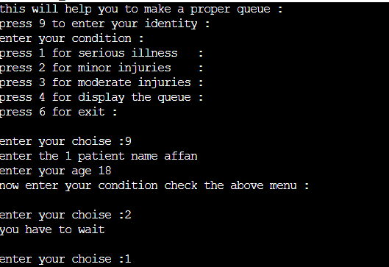

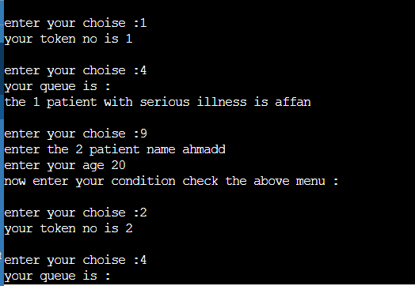

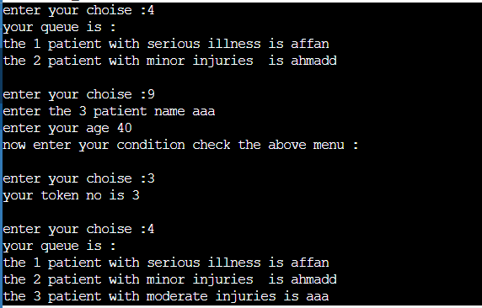

**Lab Grading Sheet :**

|  |  |  |  |
| --- | --- | --- | --- |
| **Task** | **Max Marks** | **Obtained Marks** | **Comments(*if any*)** |
| 1. | 02 |  |  |
| 2. | 03 |  |  |
| 3. | 05 |  |  |
| **Total** | **10** |  | **Signature** |

**Note : Attempt all tasks and get them checked by your Lab Instructor.**